|  |  |
| --- | --- |
| C:\Users\arielsc\Documents\Office TPM team\LOGOS\AppsLogo_rgb_Excel_Grn348.png | Power Map  Preview for Excel |
|  | Executive Demo Track |
|  | Product Marketing Manager: Ari Schorr (arielsc)  Updated: 9/19/2013 |

Demo setup

Users must have the **Office Professional Plus 2013**Suite or [**Office 365 ProPlus**](http://office.microsoft.com/en-us/business/office-365-proplus-virtual-office-online-FX103213513.aspx) installed in order to use the Public Preview of Power Map for Excel. 64-bit Excel is also recommended to prevent crashing Excel with large datasets and can be checked by going to FILE🡪Account🡪About Excel.

Make sure that Power Map Preview installed and enabled enabled by doing the following steps:

1. Download the Power Map Preview at <http://www.microsoft.com/en-us/download/details.aspx?id=38395>
2. Open the **European Expansion** workbook and click the INSERT tab.
3. Check that the **Map** icon  is in the ribbon

1. NOTE: If this icon does not appear, click FILE in the upper right to go to the “Backstage”.
2. Click **Options🡪Add-Ins🡪COM Add-ins** in the **Manage:** drop down menu. Click **Go…**

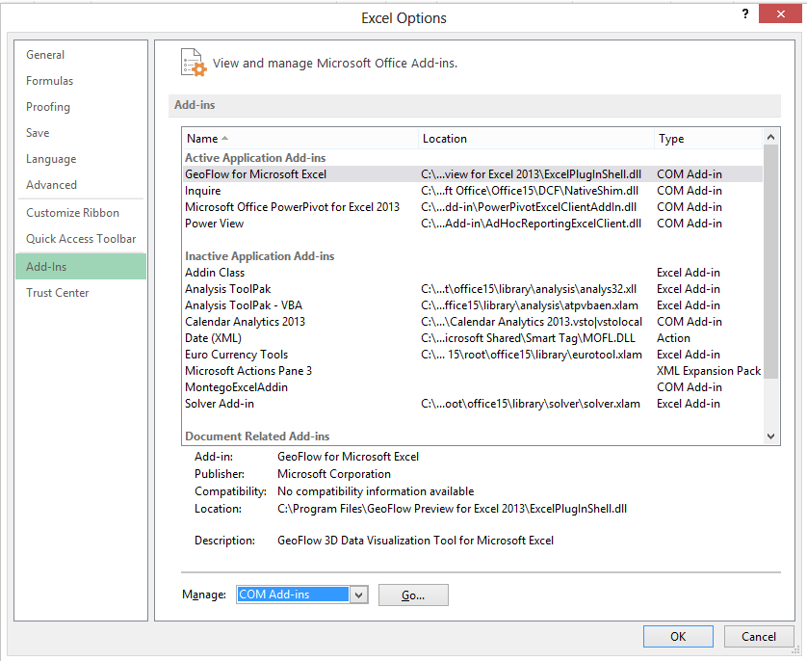

1. Enable “Microsoft Power Map Preview for Microsoft Excel” by checking the box next to each. Click **OK**.

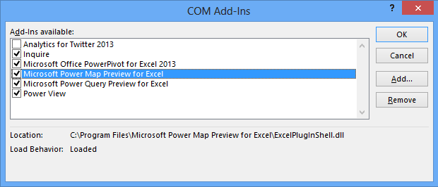

1. NOTE: You may also want to go through this same 1-6 process to ensure that **Power Query** is installed and shows up as a separate tab in the Excel Ribbon (rather than INSERT tab in step 2). This will ensure that you can provide context on how you brought your data into Excel early in the demo.

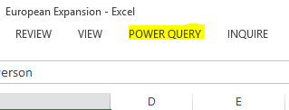

Power Query can be installed here: <http://www.microsoft.com/en-us/download/details.aspx?id=39933>

Demo

| **Talk Track** | **Click through** |
| --- | --- |
| Excel is becoming a more powerful business intelligence tool for all skill levels of information worker, especially now with the new Power BI for Office 365 offer being announced. A great example of some of the new visualization capabilities coming soon natively in Excel is **Power Map**, formerly known as Project codename “GeoFlow” Preview. In this scenario we will use Power Map to visualize geospatial and time data in Excel, then share insights within our organization as an interactive and cinematic tour to help us make an informed business decision about a European expansion of our company. | 1. Open the **European Expansion** workbook if it is not open already. |
| In order to make an informed decision, we have gathered relevant data from public data sources using another new Excel add-in called **Power Query**, formerly known as “Data Explorer” Preview. We have tables here in the workbook with EU country data on per capita income, mobile subscriptions, internet subscriptions, and internet speed. This data is also related by country in the Excel Data Model in **Power Pivot** behind the scenes. | 1. Click on any cell within the table on the **Income per Person** tab to launch the Power Query pane on the right side, showing that we brought this data into Excel using a query to a data source. *Without the add-in installed, no pane will appear.* |
| Once we have the data in our Excel workbook, we can visualize it with Power Map by simply going to the Insert tab and clicking Map. This gives a list of saved “tours” we have created. We can open up this one here to add some more data to it and then play the tour to share our insights. | 1. Click **INSERT** in the ribbon and then **Map** in the middle to launch the tour menu.      1. Click on the only tour saved called European Expansion to launch **Power Map**. |
| We already have three “scenes”, like slides, in our tour created to tell our story about where we should expand our operations in Europe but we want to add one more visualization to this last scene showing internet speeds, which could be a good indicator of potential uptake of our online offerings. We already have a layer of data showing the internet subscribers over time as a column chart so we will add a heat map that can be visualized *in addition to* this existing visualization data, allowing for deeper insights. | 1. Call out the three screenshots shown in the left pane in Power Map.   **NOTE:** The “Internet Speed” regions layer that you will create in steps 6-10 has been created for you already in the demo workbook. If you would like to show how to create a layer (show authoring in Power Map), click the **layer tab**  in the right pane, and click the  **next to Internet Speed (Regions)** to hide the layer. The regions will be removed from the map so you can show how to create it.   1. Click **Add Layer** in the ribbon to begin adding Internet Speed data to the map. |
| Our first step is to geo-code, or plot, the data on the map by sending our data off to Bing. We select our location-based data, city and country in this case although there are a number of other options, and click “Map It”. Immediately, we see the data points from our workbook show up on the map, where Power Map recognizes the columns of data that are geospatial. Now all we need is to select download speed to see the data populate on the map. We will switch from columns to heat map so that we can see both visualizations clearly and compare them. Then, we can switch it again to the new regions visualization to get an aggregation of internet speeds at the country level. | 1. Select **City** and **Country** under Internet Speed in the right field well. Be sure to pause with the Geography drop down open to show the other options. 2. Click **Map it** to geo-code the data points on the map with Bing      1. Check **download\_kps** under Internet Speed to add it to the Height field well. 2. Click the arrow for the **Chart Type drop down menu** and select **Heat Map**      1. Change the **Type** to **Region** |
| We are now ready to play the tour in order to share our insights gained from using Power Map. By simply clicking “Play Tour” we are taken into a cinematic and interactive slideshow of our insights.   1. In this first scene we see average annual income per person for different EU countries. We can pick out an outlier in Luxembourg and identify that Austria seems to be quite wealthy, good for a potential market. 2. Next we see that Austria again is a close second to Finland when looking at mobile adoption, a good indicator of market size for our new mobile offerings. 3. Lastly, we see the scene that we created with the time-lapse of internet subscribers over a heat map of internet speed, which provides us a clear insight as to why we need to be careful about expanding in Austria where internet connectivity is sparse, which may be leading to slower adoption.   Since we rely on the internet to deliver our products, we will want to investigate this further before making a decision about expanding. We can even zoom in with touch in the tour itself. As you can see, Power Map allows us to discover and share insights in 3D from our flat Excel geospatial data.  Sharing the tour and insights by sending the workbook is for those who have Excel and want to have this type of interactivity. However, for broader viewing of the tours, we have just added a new capability of Create Video. This means tours can be embedded in PowerPoint presentations or shared online. There are three options for optimizing your tours for different devices. | 1. Click **Play Tour** in the ribbon under “Tour”.      1. **Scene 1:** Average Annual Income Per Person      1. **Scene 2:** Mobile Subscriptions as % of Population      1. **Scene 3:** Internet Subscribers Over Time and Internet Speed      1. After the tour has finished and bars have stopped growing, click the screen with mouse or finger (if touch-enabled) and scroll or pinch to zoom into the Austria area. Click the Austria region to get more information on it.      1. Click the **ESC key or the back arrow** on the bottom left of the tour to get back to the Power Map creation screen. 2. Click on **Create Video** to show the different video options.       **NOTE:** It is recommended that you create the video tour (1080p format) before the demo to have to show at this point and to have a backup if Power Map is not working or you have a limited internet connection. Make sure to leave at least an hour for this to process and create the .mp4 file. |

Re-Demo setup

1. To prepare for the demo again, click on the third scene, click the **layer tab**  in the right pane, and click the **X next to Layer 4** to delete the layer you created. The regions will be removed from the map.

Additional Resources

1. Power Map Download Page: <http://www.microsoft.com/en-us/download/details.aspx?id=38395>
2. Power BI Preview Page (to register for Preview): <http://office.microsoft.com/en-us/excel/power-bi-FX104080667.aspx>
3. Power BI add-in and Getting Started Page (with sample workbooks with tours): <http://office.microsoft.com/en-us/excel/power-bi-download-add-in-FX104087144.aspx>
4. Power Map Help Page: <http://office.microsoft.com/en-us/excel-help/power-map-preview-for-excel-HA104102903.aspx?CTT=1>
5. Dallas Utilities Blog Post (with demo script and file on #3 above): <http://blogs.office.com/b/microsoft-excel/archive/2013/04/11/dallas-utilities-electricity-seasonal-use-simulation-with-geoflow-preview-and-powerview.aspx>